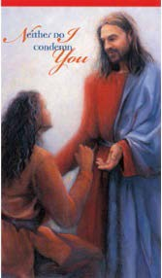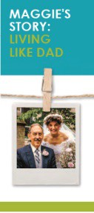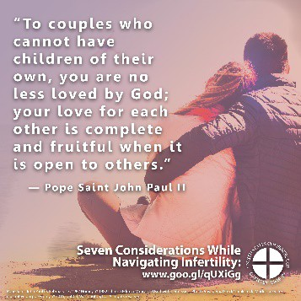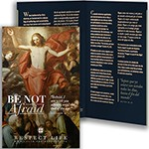WORD OF LIFE – July 2018

Bulletin Quotes

July 1
“[Religious] freedom remains one of America's most precious possessions. And, as my brothers, the United States Bishops, have reminded us, all are called to be vigilant, precisely as good citizens, to preserve and defend that freedom from everything that would threaten or compromise it.”
Pope Francis, “Address on the South Lawn of the White House,” September 23, 2015.
© 2015 Libreria Editrice Vaticana. Used with permission.
July 8
“Gracious Father, I thank you for the mercy you have shown in forgiving my sins and for the peace that comes from being reconciled with you and with your Church.”
“Trust in God’s Mercy”
USCCB Prayer Card (Post-Abortion Healing)*
Order
July 15
“Do not be afraid to embrace God’s gift of life. Whatever storms or trials we face, we are not alone. He is with us.”

USCCB Secretariat of Pro-Life Activities
2017-2018 Respect Life Reflection, www.usccb.org/be-not-afraid

Order Download
July 22
“Through [the] loving care [of my family and friends], they affirm what I also know—that my life is, always has been, and always will be, worth living.’”
“Maggie’s Story: Living like Dad,” www.usccb.org/maggies-story USCCB Secretariat of Pro-Life Activities

Order Download
July 29
“To couples who cannot have children of their own, you are no less loved by God; your love for each other is complete and fruitful when it is open to others.”
Pope Saint John Paul II’s February 13, 1982 Homily.
© 1982 Libreria Editrice Vaticana. Used with permission.

Download

WORD OF LIFE - July 2018
Bulletin Art
You are welcome to use these and other downloadable images from the online Respect Life image gallery, provided they are not altered in any way, other than the size. Thank you!

Sunday, July 15, 2018

Featuring “Accompanying Expectant Mothers Considering Adoption”
- Bulletin Insert: Color | Grayscale
- Download Image: English | Spanish

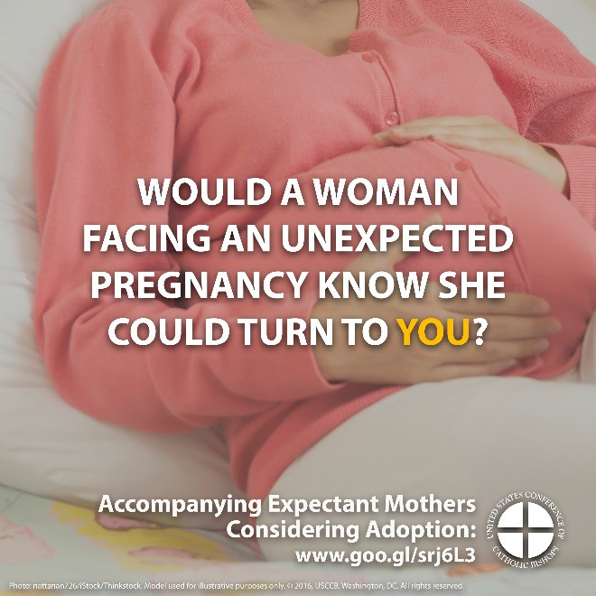
Sunday, July 22, 2018
Featuring “Caring for Loved Ones at Life’s End”
- Bulletin Insert: Color | Grayscale
- Download Image: English | Spanish

