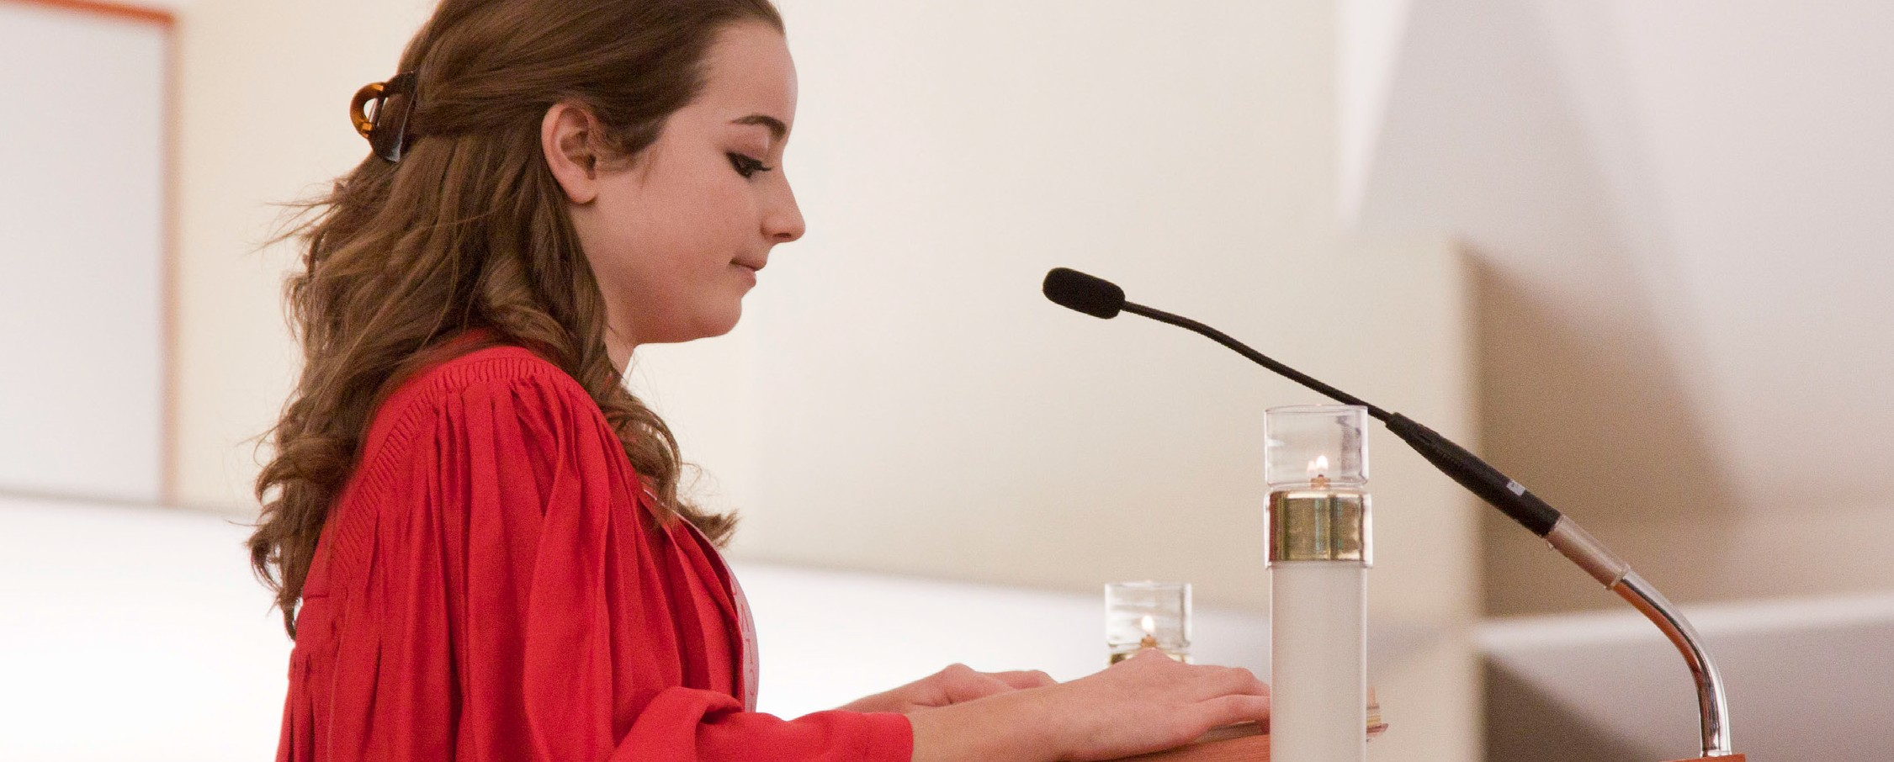
A STEWARDSHIP MOMENT

Thirteenth Sunday in Ordinary Time Weekend of June 30/July 1, 2018
In today’s second reading, St. Paul offers the community at Corinth a spirituality of giving. He urges them to give and maintains that through their generosity, they will in turn be given in return much spiritual abundance. They will receive from those who are the beneficiaries of their own giving; a reciprocal gift that amounts to an equality of giving, made possible through the generous mediation of Christ himself. This is an excellent reading for reflecting on the spirituality of giving. This week, take time to reflect on the ways you might discover a deeper joy in Jesus Christ because of your own generosity toward others.

Fourteenth Sunday in Ordinary Time Weekend of July 7/8, 2018
Today’s Gospel reveals Jesus as being amazed that the people in his hometown of Nazareth do not accept his teaching and ministry; he is taken aback by their lack of faith (Mk 6:6). Good stewards recognize and participate in Christ’s teaching, reconciling and healing presence in their community. Are we good stewards of our family of faith? Do we value and support the ministries that take place in Christ’s name? Are we attentive to the movement of the Holy Spirit in our parish and encourage those who work to enhance our life of faith?

Fifteenth Sunday in Ordinary Time Weekend of July 14/15, 2018
In his letter to the Ephesian community, St. Paul teaches that God, the Father, has established a divine plan to
bring all of creation to Christ and that He has blessed us with the divine gifts to help implement that plan. Christian stewards know what their gifts are and remain committed to using them in the service of the Lord. Do
we know what our gifts are? Do we believe that God has given us these gifts? Are we committed to using our gifts to serve the Lord?

Sixteenth Sunday in Ordinary Time Weekend of July 21/22, 2018
In today’s second reading, St. Paul reminds us that Christ is creating a new world order: one that brings about relationships based on love, peace, reconciliation,
hope and unity. As a Eucharistic community, we are stewards of Christ’s new creation. How are we promoting peace and reconciliation in our own lives? How are we showing love for our neighbors? What are we doing to encourage unity and understanding among those with whom we gather around the Lord’s Table each week?

Seventeenth Sunday in Ordinary Time Weekend July 28/29, 2018
The story of the multiplication of the loaves and the fishes is a familiar one, and has many lessons, not least of which is how our willingness to share who we are and what we have - exercising good stewardship - releases God’s power and bountifulness on the world and its people. Do we realize that there is enough for all if we are willing to share? Are we aware that God is at work when we share our time, our money and our other resources in his name?

International Catholic
Stewardship Council
ICSC@catholicstewardship.org
(800) 352-3452
www.catholicstewardship.com

