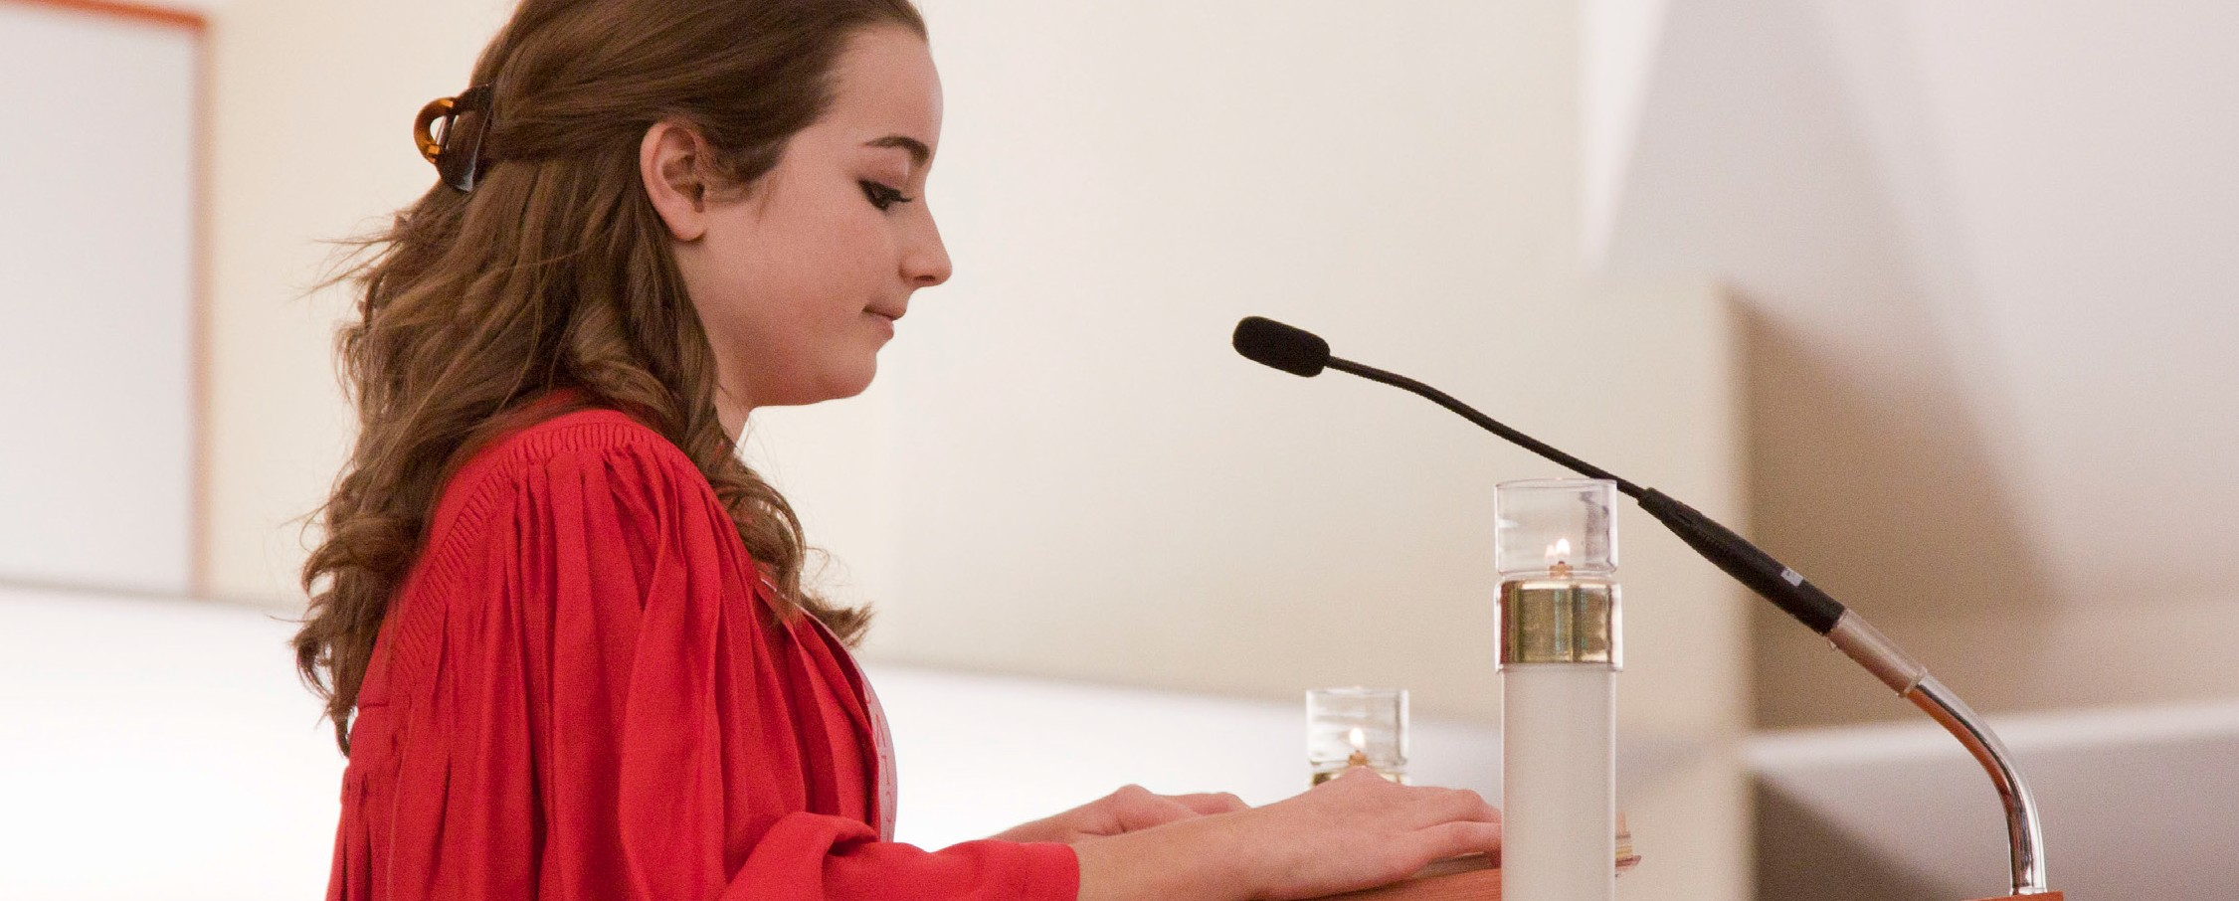
A STEWARDSHIP MOMENT

Solemnity of the Most Holy Body and Blood of Christ
Weekend of June 2/3, 2018
Today’s Gospel gives St. Mark’s account of Jesus gathering his disciples for a last supper, revealing to them a new covenant established through his own sacrificial blood.
Every time we participate in the Eucharist, we make a pledge to renew and deepen our participation in Christ’s covenant in practical ways. For the steward, that means making daily, personal sacrifices to strengthen this covenant relationship such as deepening our relationship with the Lord in prayer, supporting our parish, and giving comfort to the poor. Now is a good time to reflect on what we can do to strengthen our covenant with the Lord and our community in practical ways.

Tenth Sunday in Ordinary Time
Weekend of June 9/10, 2018
In today’s second reading Saint Paul argues that a community’s journey of faith culminates in the thanksgiving expressed in the Eucharistic meal, when the bread is broken, the cup of salvation is lifted up and the covenant with Christ is affirmed. In fact, he maintains that the entire community’s “inner nature” is constantly being renewed in hope through this thanksgiving meal.
Good stewards understand that the weekly celebration of the Eucharist is a communal gesture by which the gathered community reveals its faith and hope in the risen Lord.
Moreover, that it is a profound communal act of faith that Christ is present and active in the world at this moment. Given that understanding, what responsibilities do we take on to lift up the faith of our community? What part do we play in giving it hope?

Eleventh Sunday in Ordinary Time
Weekend of June 16/17, 2018
In today’s Gospel, Jesus compares the beginning of God’s kingdom to a mustard seed. This tiny seed, which fits in the palm of a hand, can grow to fifteen feet with sprawling branches! Like the mustard seed, the Christian community had a tiny, seemingly insignificant beginning. The church, which began with about 120 followers, added three thou- sand people on Pentecost Day following the descent of the Holy Spirit. Since then, the number of Christ’s disciples has grown incalculably and continues to grow throughout the world. Good stewards go about God’s business of “planting seeds” among all those whom they encounter.
What will we do this week to add to God’s kingdom?

The Nativity of St. John the Baptist
Weekend of June 23/24, 2018
Today we celebrate the birth of St. John the Baptist. This prophet, who practiced austerity in the desert, proclaimed the kingdom of God, a coming judgment,
and baptism as a sign of repentance. With deep humility, John directed attention not to himself but to Jesus. John’s attitude was, “He must increase, I must decrease” (John 3:30). John’s birth, days after the summer solstice when daylight hours begin to decrease, contrasts with Jesus’ birth days after the winter solstice, heralding daylight’s increase. Like John the Baptist, stewards turn attention away from themselves and towards Jesus. The stewardship question for us is whether or not we ourselves are prepared to “decrease” and allow Jesus to “increase” in our hearts, minds, words and actions.

International Catholic
Stewardship Council
ICSC@catholicstewardship.org
(800) 352-3452
www.catholicstewardship.com

