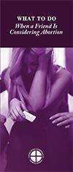WORD OF LIFE – June 2018

Bulletin Quotes

June 3rd  “In 1943, when France was occupied by German Nazis, the search for Jews began. In the face of grave peril, Sister Agnes convinced her mother superior to open their convent and offer refuge to a Jewish family. …Let us devote ourselves anew to following wherever the Lord leads. Let us take courage from their example of faith.”  USCCB Secretariat of Pro-Life Activities  “Understanding Conscience,” www.bit.ly/understanding-conscience | 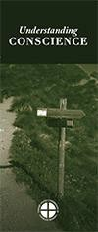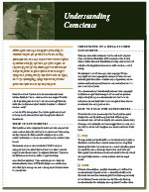  Order Download
June 10th  “To women with an unplanned pregnancy, Maya says, ‘This is survivable. Have hope.’”  USCCB Secretariat of Pro-Life Activities  “Accompanying Expectant Mothers Considering Adoption” www.usccb.org/women-considering-adoption | 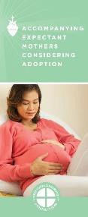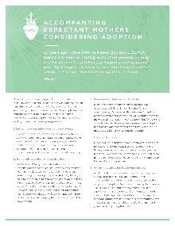  Order Download
June 17th

“If a friend told you she was pregnant and considering abortion, would you know what to do? Learn concrete tips for loving her in a way that is life-affirming for both her and her child.”

USCCB Secretariat of Pro-Life Activities
“What to Do When a Friend Is Considering Abortion”
www.usccb.org/l-o-v-e Order Download
June 24th  “Religion [cannot] be relegated to the inner sanctum of personal life, without influence on societal and national life.”  Pope Francis, Evangelii gaudium, 183.  © 2013 Libreria Editrice Vaticana. Used with permission. | www.usccb.org/ ReligiousFreedomWeek

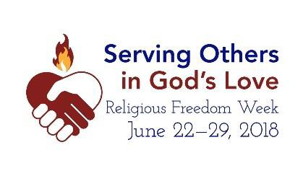View, download, and order the 2017-2018 Respect Life Program materials! www.usccb.org/respectlife
Copyright © 2018, United States Conference of Catholic Bishops, Washington, DC. All rights reserved.

WORD OF LIFE - June 2018
Bulletin Art
You are welcome to use these and other downloadable images from the online Respect Life image gallery, provided they are not altered in any way, other than the size. Thank you!

Sunday, June 3rd, 2018

Featuring “Serene Attentiveness to God’s Creation”
- Image: English | Spanish
- Bulletin Insert: Color | Black-and-White | Grayscale

Sunday, June 24th, 2018
Featuring “Religious Freedom Week 2018”
- Download Image
- More resources! www.usccb.org/ReligiousFreedomWeek

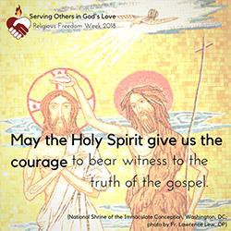

View, download, and order the 2017-2018 Respect Life Program materials! www.usccb.org/respectlife
Copyright © 2018, United States Conference of Catholic Bishops, Washington, DC. All rights reserved.

