WORD OF LIFE: JUNE 2018
Recommended dates are provided, but you are welcome to use these materials at any time!

Featured this Month…
USCCB Religious Liberty Chairman Announces Religious Freedom Week from June 22-29, 2018
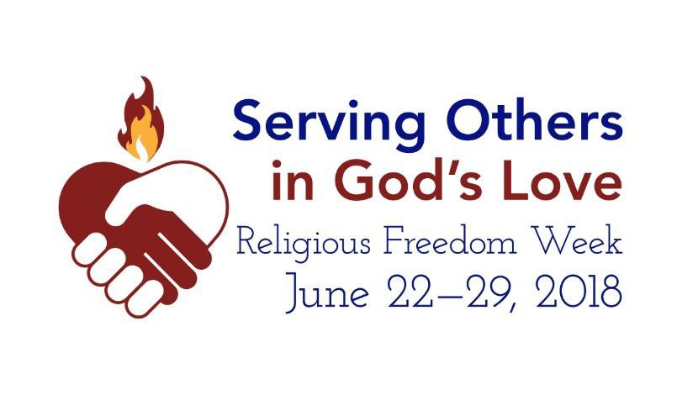April 27, 2018 WASHINGTON—Catholics across the
United States are encouraged to pray and act
in support of religious liberty at home and abroad during Serving Others in God's Love: Religious Freedom Week 2018, which begins on June 22, the Feast of Sts. Thomas More and John Fisher, and ends on June 29, the Solemnity of Sts. Peter and Paul.

The chairman of the USCCB's Committee for Religious Liberty, Archbishop Joseph E. Kurtz of Louisville, states: "Religious freedom allows the space for people of faith to serve others in God's love in ministries like education, adoption and foster care, health care, and migration and refugee services. We encourage people of faith to reflect on the importance of religious freedom so that we might have the space to carry out our mission of service and mercy, and we invite everyone to pray for our brothers and sisters who face intense persecution in other parts of the world."

Resources for Religious Freedom Week and other religious liberty resources can be found at www.usccb.org/ReligiousFreedomWeek and www.usccb.org/freedom.

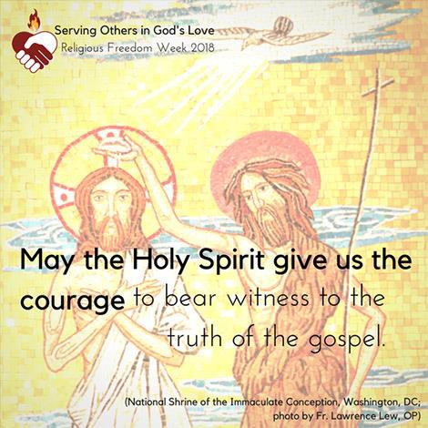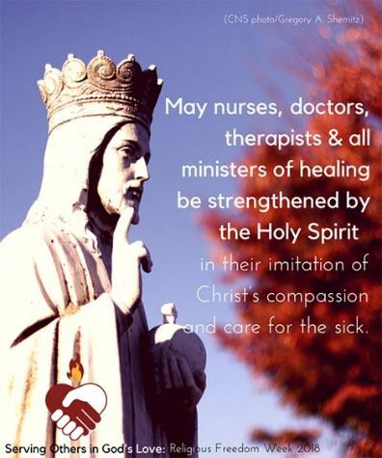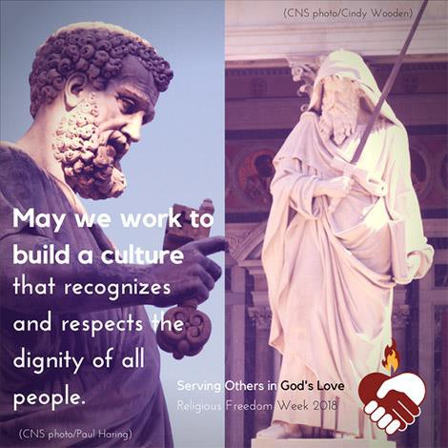

View, download, and order the 2017-2018 Respect Life Program materials! www.usccb.org/respectlife
Copyright © 2018, United States Conference of Catholic Bishops, Washington, DC. All rights reserved.

