WORD OF LIFE – MAY 2018

Bulletin Quotes

May 6th  “Sometimes our actions speak for themselves; other times, words are needed. Whatever the situation, Jesus knows how to speak to each person's heart; we simply need to follow where he leads.”  USCCB Secretariat of Pro-Life Activities  “How to Build a Culture of Life,” www.usccb.org/culture-of-life | 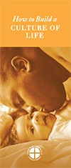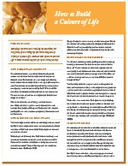  Order Download
May 13th  “We can all help encourage our government and other institutions to support life. They must always aid and support mothers and children, and never offer to pay for the destruction of life as a ‘solution’ to the challenges women face. The call to uphold women’s dignity and well-being, and that of their unborn children, is one and the same.”  USCCB Secretariat of Pro-Life Activities  “Poverty and Abortion: A Vicious Cycle,” www.bit.ly/poverty-abortion | 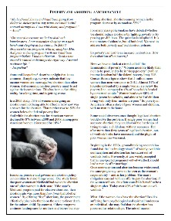  Download
May 20th  “Even among terminally ill patients, a request to die is nearly always a cry for help. … The patient requesting assisted suicide is often asking, ‘Does anyone want me to be alive, or care enough to talk me out of this request and support me through this difficult time?’”  USCCB Secretariat of Pro-Life Activities  “Every Suicide is Tragic,” www.bit.ly/every-suicide-tragic | 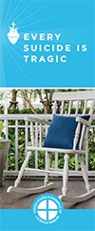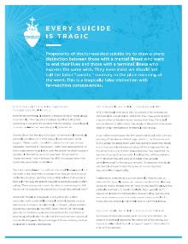  Order | Download
May 27th  “Reflecting on the healed wounds of the Risen Christ, we see that even our most difficult trials can be the place where God manifests his victory. He makes all things beautiful. He makes all things new.”  USCCB Secretariat of Pro-Life Activities  2017-2018 Respect Life Reflection, www.usccb.org/be-not-afraid | 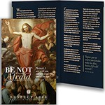  Order Download

View, download, and order the 2017-2018 Respect Life Program materials! www.usccb.org/respectlife
Copyright © 2018, United States Conference of Catholic Bishops, Washington, DC. All rights reserved.

WORD OF LIFE - MAY 2018
Bulletin Art
You are welcome to use these and other downloadable images from the online Respect Life image
gallery, provided they are not altered in any way, other than the size. Thank you!

Sunday, May 20th, 2018
Featuring “Every Suicide is Tragic”
- Image: English | Spanish
- Article: English | Spanish

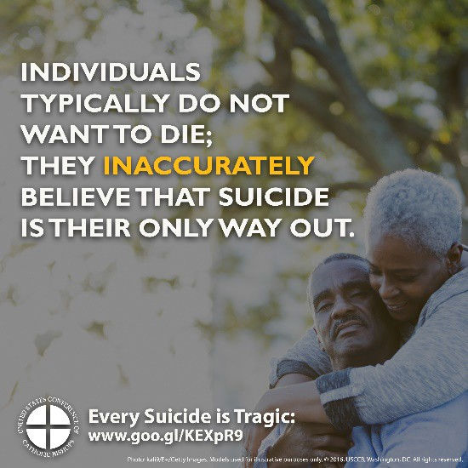

Sunday, May 27th, 2018
- Download Image: English | Spanish
- Reflection: English | Spanish

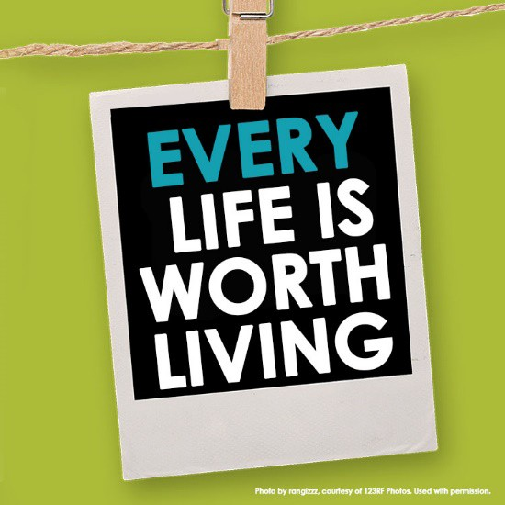

View, download, and order the 2017-2018 Respect Life Program materials! www.usccb.org/respectlife
Copyright © 2018, United States Conference of Catholic Bishops, Washington, DC. All rights reserved.

