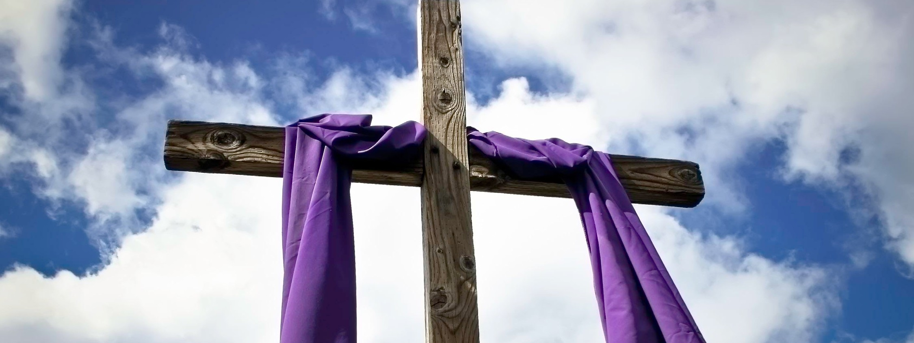
A STEWARDSHIP MOMENT

Third Sunday of Lent | Weekend of March 3/4, 2018
If your parish celebrates the Mass for the First Scrutiny for catechumens preparing for Baptism at the Easter vigil, you may hear the Gospel story of Jesus speaking with the Samaritan woman at the well; someone who supposedly is of the wrong gender, wrong religion, and has lived
the wrong life. The woman is overwhelmed by guilt and shame. And yet Jesus speaks to her and offers her “living waters” to quench her spiritual thirst. The living water that Jesus gives is new life through the Holy Spirit; a life that
is accepted, forgiven, loved and eternal. Good stewards of their life in Christ remain mindful of their own spiritual thirst. They listen to Jesus who speaks to them just as he spoke with the Samaritan woman at the well. Jesus has living water for us today. He encourages us to come and drink. Are you thirsty? Are you ready to listen to him?

If your parish does not celebrate the Mass for the First Scrutiny for catechumens, you may hear the Gospel story of Jesus’ cleansing of the Temple, a familiar story. The prophets Jeremiah, Zechariah and Malachi prophesied that when the Kingdom of God was at hand, the Temple would be cleansed of all activities unworthy of an encounter with God. Christians are often referred to as “Temples of the Lord.” As stewards of a “Holy Temple” God has entrusted to each one of us, what are we doing to be cleansed of activities unworthy of an encounter with the Lord? This week, reflect on one thing you can do to cleanse the Temple God has given you so that it becomes a more inviting home for Christ Jesus.

Fourth Sunday of Lent | Weekend of March 10/11, 2018
If your parish celebrates the Mass for the Second Scrutiny for catechumens preparing for Baptism at the Easter
vigil, you may hear the Gospel story of how a man born blind came to be a disciple of Jesus Christ. Jesus and his disciples are walking along when they encounter the man. The disciples ask a question that reflects a narrow understanding of God’s mercy. They assume that if people
suffer, then they must have done something bad to deserve it. In the case of a man born blind, it had to be something done by his parents. But Jesus says: “Neither he nor his parents sinned; it is so that the works of God might be made visible through him…” Good stewards know that God is working in their lives so that through their lives, God’s goodness will be revealed. How is God working in you? Do you see God’s goodness reflected in your life?

If your parish does not celebrate the Mass for the Second Scrutiny for catechumens, you may hear the Gospel story of Jesus’ encounter with Nicodemus, a Pharisee and leader of the Jews who comes to Jesus by night, recognizing Jesus as a teacher from God, but coming in secret for fear of being put out of the synagogue. Jesus
rebukes him for his lack of understanding. Good stewards realize that for the sake of this world, God gives his most cherished beloved son. And so they are willing to confess Jesus as their Lord and savior in a public way. They do not keep their faith to themselves, in darkness. The Gospel reading challenges us to profess our faith in word and deed publicly, not to hide it away. Are we willing to accept the Gospel’s challenge? Are we willing to get out of our personal “comfort zone” and confess our faith in Christ Jesus in an open, tangible way?

Continued on next page

A STEWARDSHIP MOMENT continued

Fifth Sunday of Lent | Weekend of March 17/18, 2018
If your parish celebrates the Mass for the Third Scrutiny for catechumens preparing for Baptism at the Easter vigil, you may hear the Gospel story of Jesus raising his friend, Lazarus, from the dead. One of the many lessons learned from this Gospel story is that of Martha’s confession of faith in her friend: “Yes, Lord. I have come to believe that you are the Christ, the Son of God, the one who is coming into the world.” Raising Lazarus from the dead was a miracle and a clear display of God’s power. It was
also an unmistakable sign that Jesus was the Christ. Good stewards of their faith see signs of Christ’s presence
all around them and are eager to respond in faith. The stewardship question for us is: Who or what will be the Lord of our lives? Will it be Christ Jesus? And if so, how will we respond to him? Are we willing to walk in his footsteps and follow his example?

If your parish does not celebrate the Mass for the Third Scrutiny for catechumens, you may hear the Gospel story of Jesus inviting his disciples into a great mystery with curious pronouncements: Those who love their lives just as they are will lose them. If a grain of wheat dies, it will bear much fruit…What does Jesus mean? The climactic event
of Jesus’ passion and death is drawing closer; a time when the great confrontation between Jesus and the powers of darkness take place. When Jesus is lifted up, he will draw all to himself. The Christian steward knows life can’t be lived in complacency. We are called to die to self, bear more fruit, be raised up with Jesus. Jesus brings discomfort to those who are comfortable. Jesus urges us to give witness in his name. How will we respond?

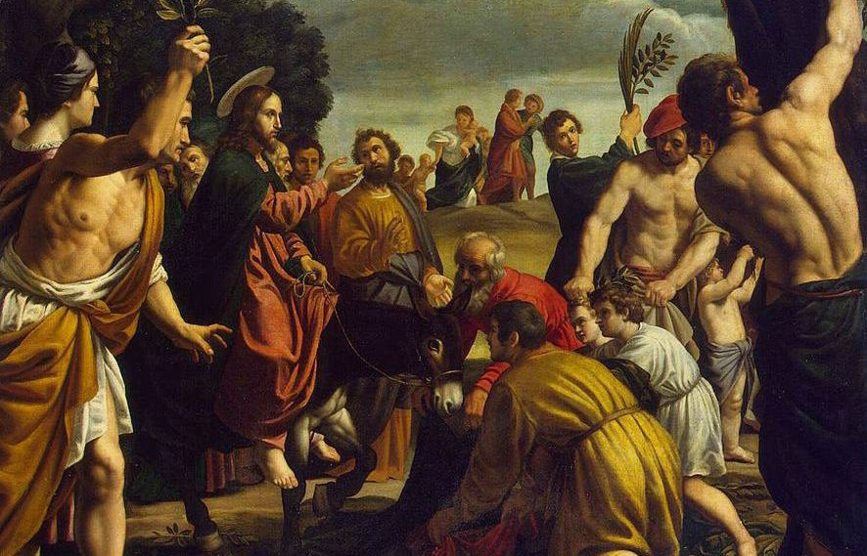Palm Sunday of the Lord’s Passion | Weekend of March 24/25, 2018
This weekend we participate in the proclamation of the passion and death of Jesus according to the Gospel of Mark. In the extended version of this weekend’s Gospel reading, Jesus is at Gethsemane, praying to his Father, in much emotional distress. He knows he can save himself. He can escape over the Mount of Olives in the dead of night and make his way safely into the Judean desert. Instead, Jesus chooses obedience to his Father and
waits for his persecutors. As Saint Paul puts it in the second reading, Jesus is “obedient to the point of death.” Jesus’ obedience is a lesson for those who are good stewards of their life in Christ. Let us reflect on how we might be more obedient to the will of God instead of our own will.

International Catholic
Stewardship Council
ICSC@catholicstewardship.org
(800) 352-3452
www.catholicstewardship.com

