Word of Life – March 2018

Bulletin Quotes

March 4th  “O God our Creator… give us courage in making our voices heard on behalf of the rights of your Church and the freedom of conscience of all people of faith.”  USCCB, “Prayer for the Protection of Religious Liberty” www.bit.ly/ReligiousLibertyPrayer | 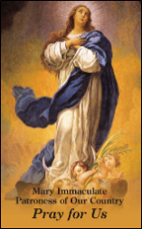  Order | Download
March 11th  “When I voiced my objections to do abortion-related services, I was terminated. It’s against my conscience. I became a nurse to protect lives, not to take lives.” – Sandra Mendoza, L.P.N.  Take Action: www.humanlifeaction.org  Video: www.bit.ly/StandWithSandra | 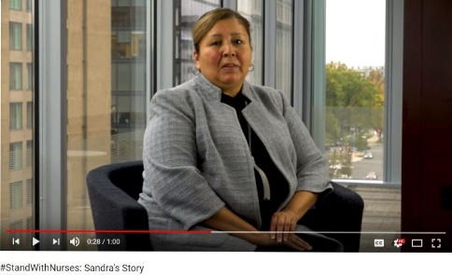  View Online
March 18th  “When God created each of us, He did so with precision and purpose… let us treat each person as the masterpiece that he or she is.”  USCCB Secretariat of Pro-Life Activities  Respect Life Flyer: “Each of Us is a Masterpiece of God’s Creation” www.bit.ly/GodsMasterpieces | 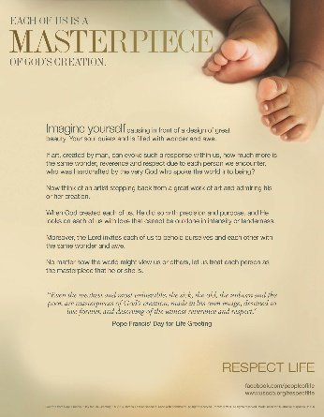  Download
March 25th  “Respect for the human person proceeds by way of respect for the principle that ‘everyone should look upon his neighbor (without any exception) as “another self,” above all bearing in mind his life and the means necessary for living it with dignity.’”  Catechism of the Catholic Church, 1931. www.bit.ly/CCC1931 |  | 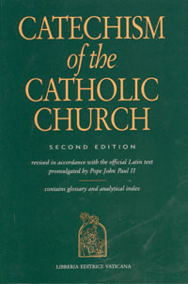  Order | View Online

View, download, and order the 2017-2018 Respect Life Program materials! www.usccb.org/respectlife
Copyright © 2018, United States Conference of Catholic Bishops, Washington, DC. All rights reserved.

Word of Life - March 2018

Bulletin Art
You are welcome to use these and other downloadable images from the online Respect Life image gallery, provided they are not altered in any way, other than the size. Thank you!

Sunday, March 4th, 2018

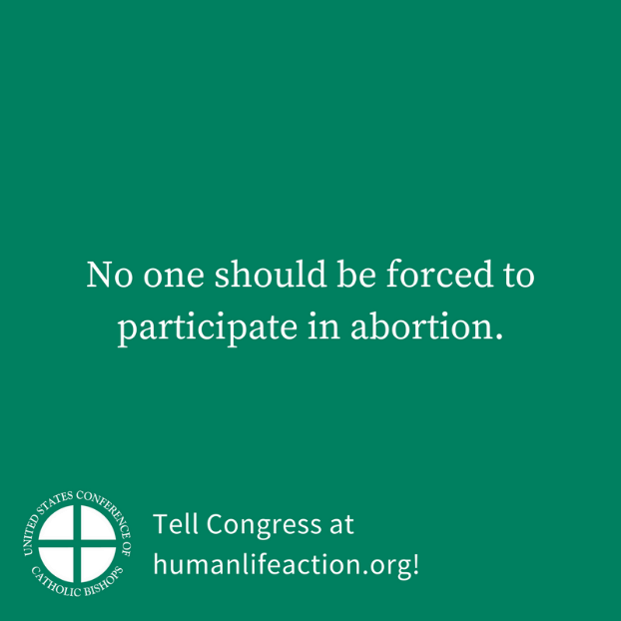
Download Image: English | Spanish

Sunday, March 11th, 2018

Download Image: English | Spanish

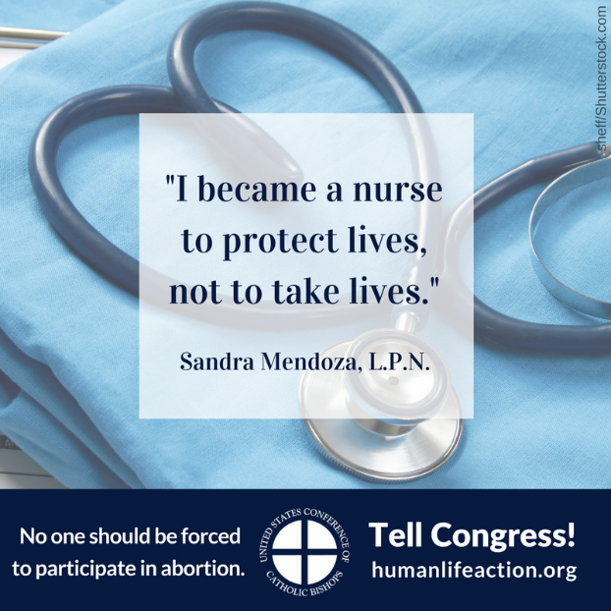

View, download, and order the 2017-2018 Respect Life Program materials! www.usccb.org/respectlife
Copyright © 2018, United States Conference of Catholic Bishops, Washington, DC. All rights reserved.

