Word of Life – January 2018

Bulletin Quotes
January 1st  “To women with an unplanned pregnancy, Maya says, ‘This is survivable. Have hope.’”  USCCB Secretariat of Pro-Life Activities  “Accompanying Expectant Mothers Considering Adoption,” www.goo.gl/srj6L3 | 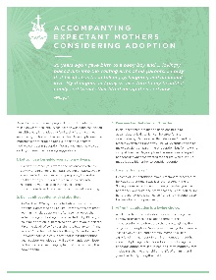  Order Download
January 7th  “Heavenly Father, thank you for the precious gift of life. Help us to  cherish and protect this gift, even in the midst of fear, pain, and  suffering. … Grant us the humility to accept help when we are in need,  and teach us to be merciful to all.”  USCCB Secretariat of Pro-Life Activities  “Every Life is Worth Living” Prayer Card, https://goo.gl/iF9daj | 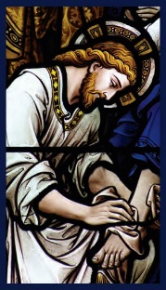  Order Download
January 14th  “Pray with a multi-faceted novena that includes a new intention, brief reflection, bonus information, and suggested actions each day. Sign up now & participate Thursday, January 18 – Friday, January 26: 9daysforlife.com”  USCCB Secretariat of Pro-Life Activities  www.9daysforlife.com | 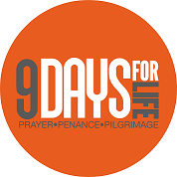  Learn more!
January 21st  “When a woman is facing a difficult pregnancy, the reaction of the first person she tells tends to set the tone for her decision-making. How do we respond in a loving way that is life-affirming for both her and her baby?” Find out in “What to Do When a Friend is Considering Abortion: www.bit.ly/friend-considering-abortion.  USCCB Secretariat of Pro-Life Activities  “What to Do When a Friend Is Considering Abortion”  www.bit.ly/friend-considering-abortion | Order Download
January 28th  If a friend confided in you tomorrow that she had an abortion, would you be able to respond in a way that brings her closer to healing? Learn what to do and say in “How to Talk to a Friend Who’s Had an Abortion”: www.bit.ly/friend-had-abortion.  USCCB Secretariat of Pro-Life Activities  “How to Talk to a Friend Who’s Had an Abortion” | Order

View, download, and order the 2017-2018 Respect Life Program materials! www.usccb.org/respectlife
Copyright © 2017, United States Conference of Catholic Bishops, Washington, DC. All rights reserved.
Word of Life - January 2018

Bulletin Art
You are welcome to use these and other downloadable images from the online Respect Life image gallery, provided they are not altered in any way, other than the size. Thank you!

Sunday, January 1st, 2018
Be sure to visit the 9 Days for Life leaders’ toolkit!
Featuring “Living out Christmas in the New Year”
- Download Text: English | Spanish
- Download Image: English | Spanish
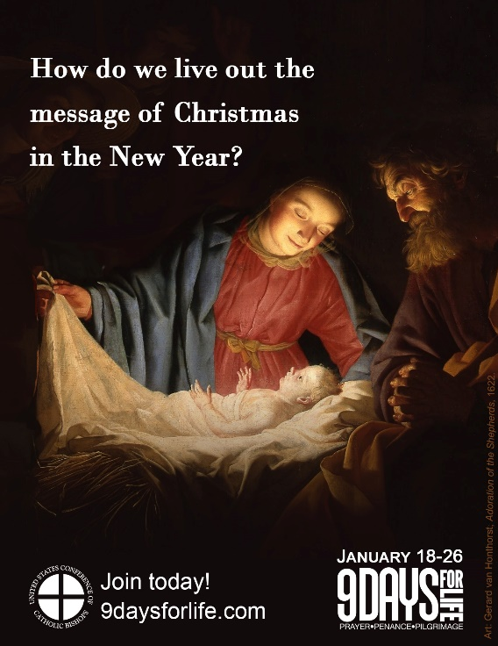

Sunday, January 14th, 2018
Featuring “9 Days for Life”
- Bulletin Insert: Color | Grayscale
- Download Image: English | Spanish

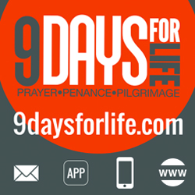

View, download, and order the 2017-2018 Respect Life Program materials! www.usccb.org/respectlife
Copyright © 2017, United States Conference of Catholic Bishops, Washington, DC. All rights reserved.

