Word of Life: January 2018
Recommended dates are provided, but you are welcome to use these materials at any time!

9 Days for Life: January 18-26, 2018
www.9daysforlife.com
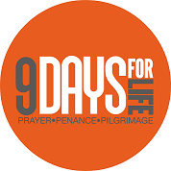
9 Days for Life is a “digital pilgrimage” of prayer and action focused on cherishing the gift of every person's life. A multi-faceted novena highlighting a different intention each day provides reflections, bonus information, and suggested actions.
Sign up to receive the novena through a free app, daily emails, or daily text messages. Visit www.9daysforlife.com to sign up and for information on how else you can get involved!
#9DaysforLife #OurPrayersMatter
Day of Prayer for the Legal Protection of Unborn Children: January 22, 2018
- Description
- Leaders’ Resources (includes choices of readings for Mass, homily notes, intercessions, and more)

9 Days for Life Leaders’ Toolkit

- Bulletin Insert
- Pulpit/Bulletin Announcements
- Novena
- Graphics
- Leaders’ Guide for Ministry to Young People
- More!

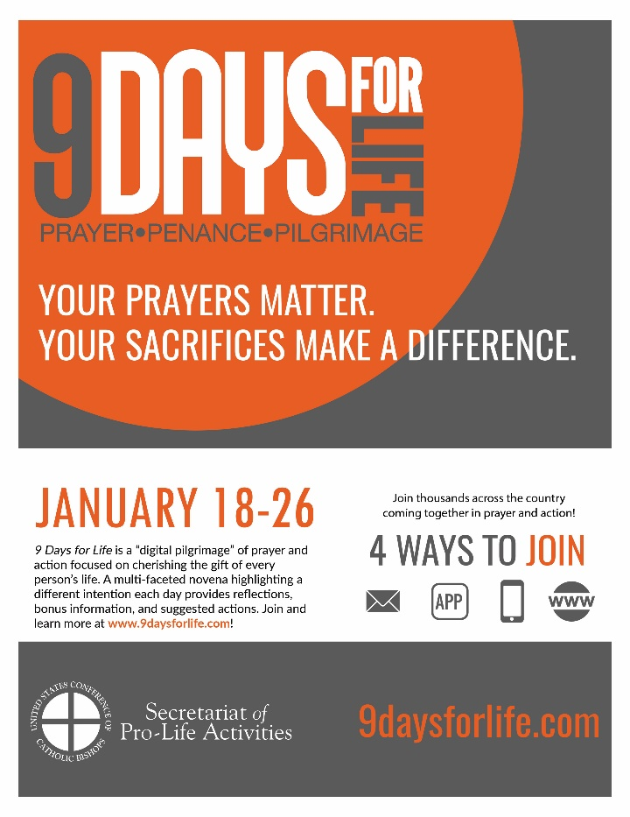

View, download, and order the 2017-2018 Respect Life Program materials! www.usccb.org/respectlife
Copyright © 2017, United States Conference of Catholic Bishops, Washington, DC. All rights reserved.

