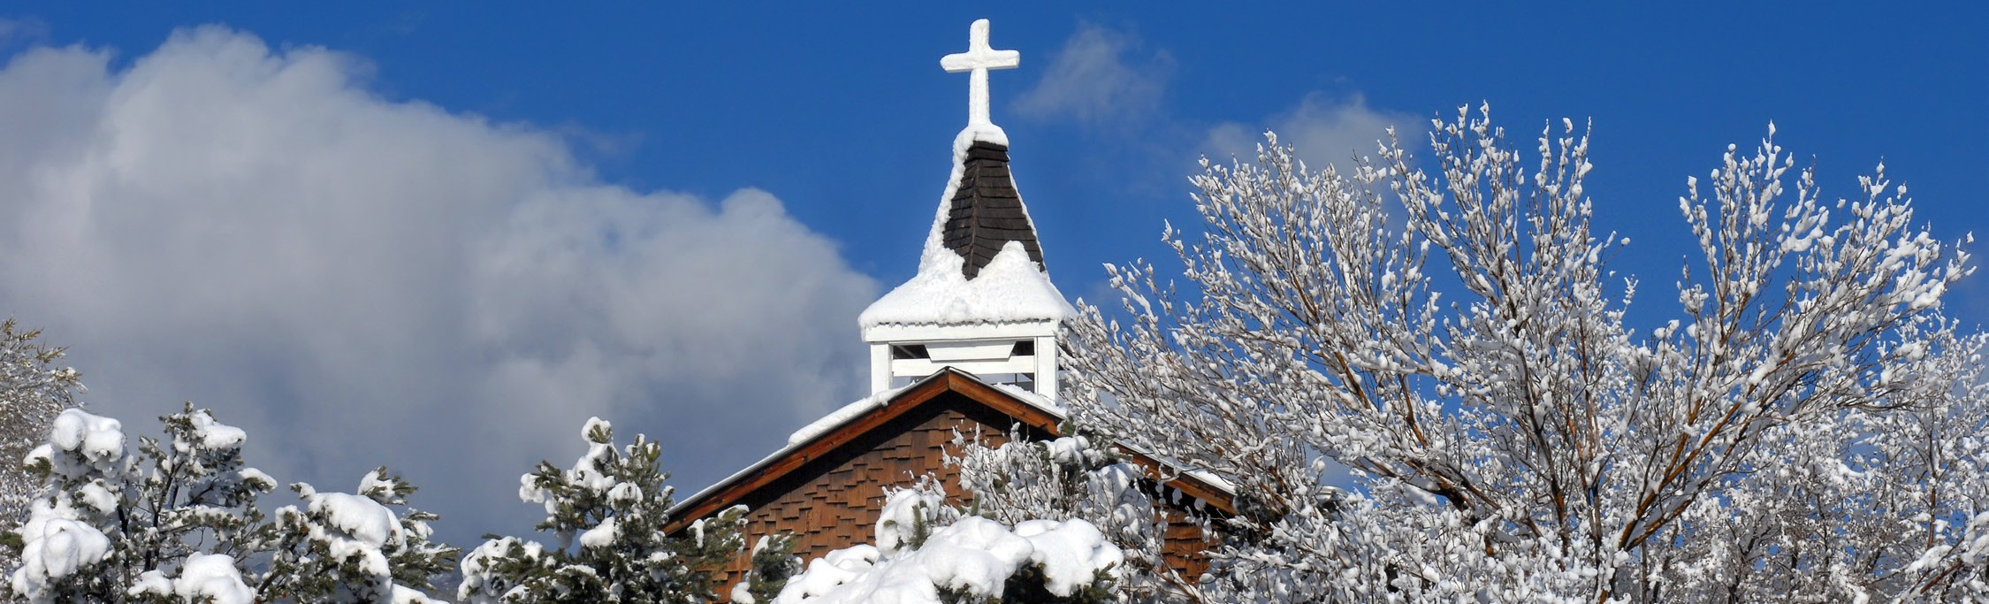
A STEWARDSHIP MOMENT

The Solemnity of Mary, the Holy Mother of God January 1, 2018
In today’s Gospel we again hear the story of the nativity from Saint Luke; of the motherhood of Mary, the vessel who brought forth our savior in a dark corner of the world and reflected on this sacred revelation in her heart. Christian stewards are also the vessels by which Christ is carried out into the world. They continually seek ways to reveal Jesus in the world’s dark corners. In this new year, let us ask God to give us the courage to bring forth Christ to those who are strangers to us, who think differently than we do or who may not believe that Christ can make a difference in their lives.

Feast of the Epiphany of the Lord
For the weekend of January 6/7, 2018
Today’s Gospel reading reveals the story of the magi who come from the east to pay homage to Jesus, the newborn king. The story of the magi teaches Christian stewards three Christmas truths: God, in the person of Jesus Christ, is present and active in the world, and good stewards strive daily to follow his star. Second, each of us, no matter our circumstances or station in life, has a gift to bring to the Lord. And finally, our life’s journey always leads to Christ, even when at times we do not know where the road is taking us.

Second Sunday in Ordinary Time Weekend of January 13/14, 2018
Christian stewardship begins with the call to discipleship and in today’s Gospel we discover those first individuals who sought out Jesus and wanted to listen to him, learn from him and stay with him. Today, Christian stewards search out the hidden presence of Jesus in their own lives every day. They know Christ is the “Messiah” who will one day bring about a perfect restoration to a troubled
world. They further understand that they are sacraments of his hidden presence in the world. Their task is to make that reality known through their own words and actions. What is one thing we can do to be better stewards of Christ’s life in us?

Third Sunday in Ordinary Time Weekend of January 20/21, 2018
The first disciples of Jesus in today’s Gospel left their work and their daily routines to follow him. They abandoned their livelihoods, familiar surroundings and the lives to which they had become accustomed to be closer to him. The good steward finds ways to be removed from what may be a comfortable existence or daily routine in order to serve the Lord more faithfully. All too often, out of
fear, insecurity or even selfishness, we refuse to leave the safety of the little world we have created for ourselves
in order to hear the Lord’s call and be challenged by his Gospel. Perhaps we should reflect on what comforts we need to sacrifice in order to be better stewards of God’s mercy, compassion and hospitality he planted within us.

Fourth Sunday in Ordinary Time Weekend of January 27/28, 2018
In today’s Gospel we hear proclaimed the beginning of Jesus’ public ministry. He teaches. He heals. And all are amazed. By their baptism, Christian stewards realize they are called to do the same in their lives. They are called
to be the light of Christ each day. As we bring closure to the beginning of this new year, now is a good time to ask the Lord to fill our hearts with courage and faith, so that we too may publicly minister in his name; that we may be liberated from our insecurities and fear so that we can share the Gospel authoritatively and work to heal at least one wounded relationship in the coming months ahead.

International Catholic
Stewardship Council
ICSC@catholicstewardship.org
(800) 352-3452
www.catholicstewardship.com

