Word of Life – December 2017

Bulletin Quotes
December 3rd  “When we encounter Christ, experience his love, and deepen our relationship with him, we become more aware of our own worth and that of others.”  USCCB Secretariat of Pro-Life Activities  “How to Build a Culture of Life,” www.goo.gl/yAt6Gk | 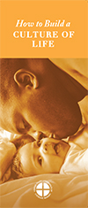  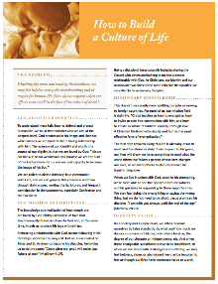  Order Download
December 10th  “If you know someone who has had an abortion, express your sympathy for her loss. Assure her of God’s unconditional love, and encourage her to seek healing and forgiveness.”  USCCB Secretariat of Pro-Life Activities  “Bridges of Mercy for Post-Abortion Healing,” www.goo.gl/MpC7RG | 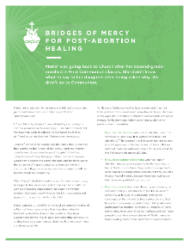  Order Download
December 17th  “He is always with us. Jesus promised this when he gave the disciples the same mission he gives to each of us: Go. … Walk with each other. Do not be afraid to embrace God’s gift of life. Whatever storms or trials we face, we are not alone. He is with us.”  USCCB Secretariat of Pro-Life Activities  2017-18 Respect Life Reflection, www.bit.ly/2x31e1X | 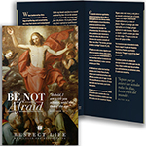  Order Download
December 25th  “An unexpected pregnancy can be a difficult and frightening time, and it’s important that your friend knows you are thinking of her and supporting her. …Your support might be the only support she receives. Even if we never know how, the smallest things we do can change someone’s life.”  USCCB Secretariat of Pro-Life Activities  “10 Ways to Support Her When She’s Unexpectedly Expecting,” www.bit.ly/10WaysRespectLife | 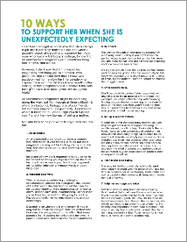  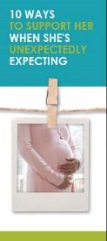  Order Download
December 31st  “Your own quiet, patient presence can provide important support as your loved one prepares emotionally and spiritually for his or her passing.”  USCCB Secretariat of Pro-Life Activities  “Caring for Loved Ones at Life’s End,” www.goo.gl/fvSEYp | 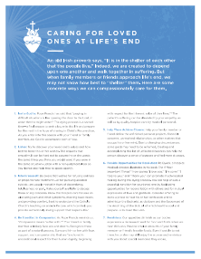  Order Download

Word of Life - December 2017

Bulletin Art
You are welcome to use these and other downloadable images from the online Respect Life image gallery, provided they are not altered in any way, other than the size. Thank you!

Sunday, December 10th, 2017
If you have any issues with file security settings, please email prolife@usccb.org.
Featuring “Bridges of Mercy for Post-Abortion Healing”
- Bulletin Insert: English | Spanish (other formats)
- Download Image: English | Spanish

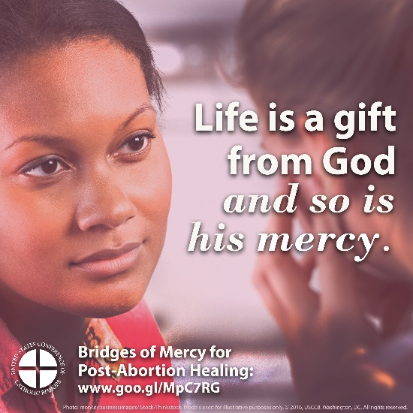

Sunday, December 24th, 2017
Featuring “10 Ways To Support Her When She's Unexpectedly Expecting”
- Bulletin Insert (color): English | Spanish
- Bulletin Insert (grayscale): English | Spanish
- Download Image: English | Spanish

