Word of Life: December 2017
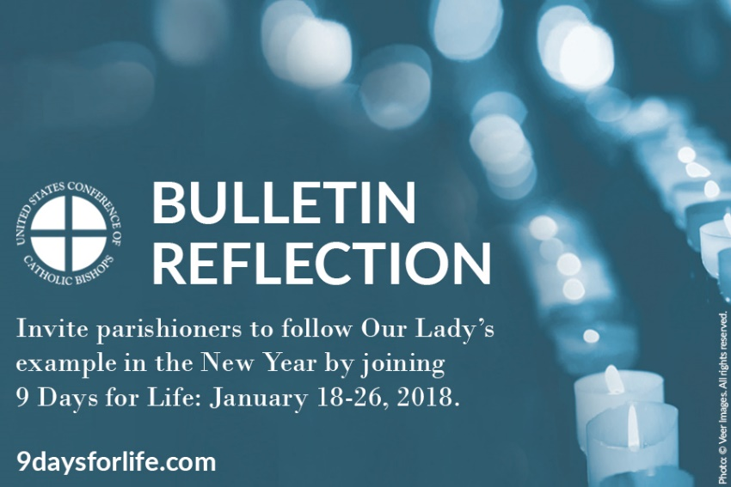
Recommended dates are provided, but you are welcome to use these materials at any time!
FEATURED THIS MONTH
WHAT: A brief reflection inviting people to join 9 Days for Life from January 18 – January 26, 2018.
WHEN: Suggested for use the weekend of December 30-31 or the weekend of January 6-7, but can be used any time.
WHERE: Use for your parish bulletin, e-newsletter(s), website, social media, or anywhere else you communicate.
HOW: Copy and paste the text below into your bulletin or other communications. Download the image below, and use it with the text or on its own.

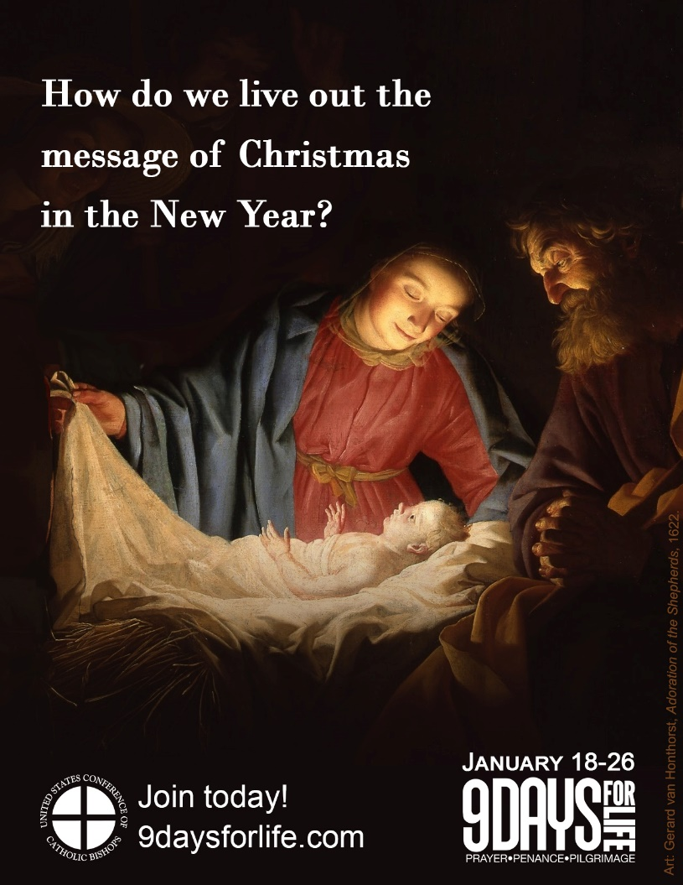
Living out Christmas in the New Year
How do we live out the message of Christmas in the New Year, rather than pack it away with the ornaments?
Each year the Octave Day of Christmas falls on the first day of the New Year, on which we also celebrate the Solemnity of the Blessed Virgin Mary, the Mother of God.
Her open heart and courageous “yes” to God show us how to live year-round—with hearts open to the Lord, following where He leads. We are called to place our trust in Him, to enter compassionately into the suffering of others, and to love one another as Christ loves us. Like Our Blessed Mother welcomed Jesus, we are called to cherish and protect the gift of human life, at every stage and in every circumstance.
One way to live out the message of Christmas and follow Our Lady’s example is to join 9 Days for Life, a digital pilgrimage of prayer and charitable action.
The U.S. Catholic bishops invite you to join thousands of Catholics nationwide from Thursday, January 18 – Friday, January 26.
Join today at www.9daysforlife.com!

