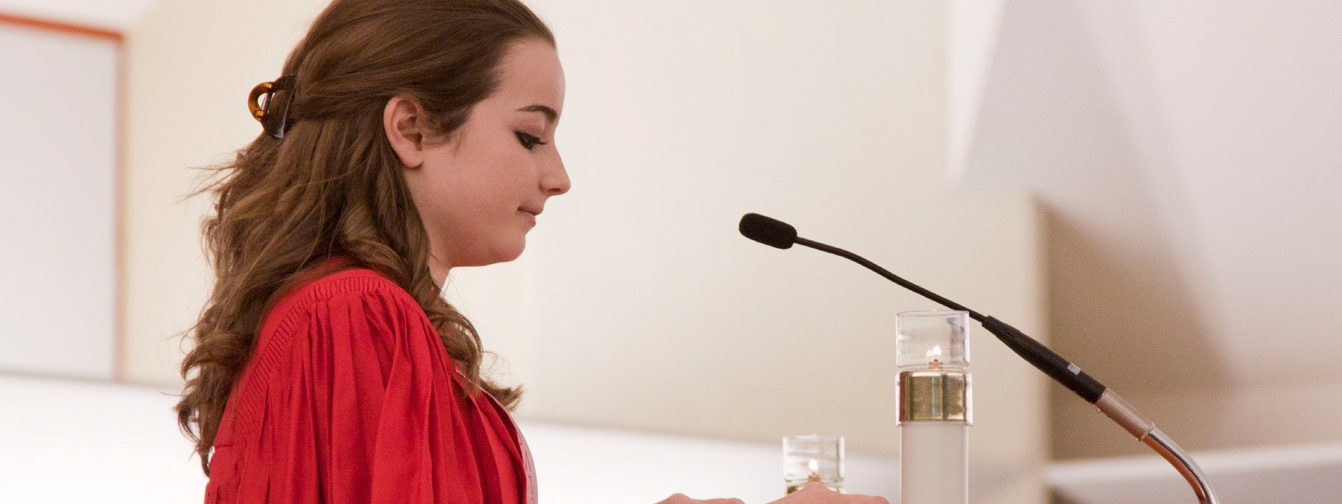
A STEWARDSHIP MOMENT

Thirty-first Sunday in Ordinary Time Weekend of November 4/5, 2017
In today’s Gospel, Jesus lays judgment on the scribes and Pharisees for the hypocritical way they lived out their faith. The criticisms he levies are all about the ways righteousness turns into self-righteousness, and how religious belief turned into something that was more about elevating themselves than about what they could do for God or their neighbor. Good stewards know that
discipleship means finding ways to serve, and searching for ways to be a servant—to live as a servant of Christ. When faith is authentically lived out in community everyone is enriched, and God is glorified. Reflect this week on how you live out your faith.

Thirty-second Sunday in Ordinary Time Weekend of November 11/12, 2017
Jesus compares the kingdom of heaven with ten virgins who took their lamps and went out to meet the
bridegroom. Five of them were foolish and five of them were prudent. The foolish did not prepare for the wait, they brought no extra oil to keep their flames burning bright. The prudent bridesmaids brought extra oil, just in case the wait was longer than they had expected. And the wait was long. Some of those who were supposed to be waiting were not prepared for the wait, with disastrous consequences. Good stewards heed Jesus’ warning: Be prepared to wait for the Lord’s return. Is your faith strong
enough to endure the wait? Will the “flames” of passion for the Lord endure? What are you doing to keep your passion for the Lord from burning out?

Thirty-third Sunday in Ordinary Time Weekend of November 18/19, 2017
In today’s Gospel, Jesus delivers the parable of the talents; using the example of money rather than abilities or skills. It’s a story about investments, risks and returns. Stewards understand that God has given them an abundance of spiritual gifts. They know God doesn’t want them to simply receive these blessings and bury them in fear, but to multiply them; to use these gifts to serve Him and others; to spread Christ’s Good News; to go and make disciples
of others. Good stewards invest what God has given them in the service of others and are prepared to render an account when the Lord returns. Reflect this week on how you are returning your own God-given gifts back to God with increase.

Feast of Our Lord Jesus Christ, King of the Universe Weekend of November 25/26, 2017
In today’s Gospel, Saint Matthew offers a compelling vision of the end-time, when the people of all nations are brought before the Lord to give an account of their lives and actions. Interestingly, the sheep, the righteous ones, are rewarded for having acted with love and compassion without having recognized the face of Christ in others.
Good stewards recognize those in need of their care as gifts from God. They know that they are instruments of Christ’s active, loving presence in the world. How will we treat others this week: our family members, neighbors, customers, strangers? What accounting will we make to the Lord for their care?

International Catholic
Stewardship Council
ICSC@catholicstewardship.org
(800) 352-3452
www.catholicstewardship.com

