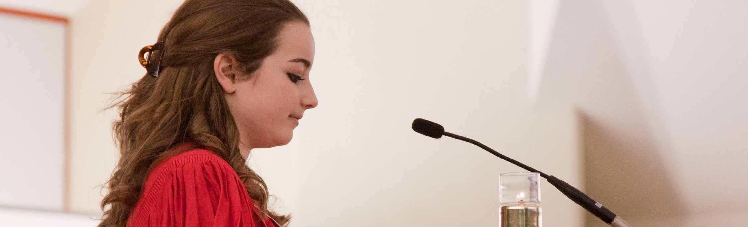
A STEWARDSHIP MOMENT

Twenty-Sixth Sunday in Ordinary Time Weekend of September 30/October 1, 2017
Saint Augustine, a doctor of the church, once wrote that the first, second, and third most important attitude in Christianity is humility. In today’s second reading, Saint Paul is concerned with how we conduct ourselves in our community of faith. He urges us to let our conduct be worthy of the Gospel we say that we believe; and that it all begins with humility. He asks us to consider others better than ourselves, and to serve them by looking out for their best interest, not ours. Consider how Saint Paul’s appeal to imitating Christ’s humility can enhance your relationships.

Twenty-seventh Sunday in Ordinary Time Weekend of October 7/8, 2017
Today’s Gospel reading poses some challenging stewardship questions. When Christ returns, will we be found working diligently in the Lord’s “vineyard;”
converting our own hearts into a rich harvest of love and compassion? Calling those outside our vineyard to enter into the joy of the Lord? Or will we just be living, taking advantage of what the Lord has given us, but not doing our part in return? Jesus’ parable suggests that if we aren’t good stewards of the gifts we’ve been given then the gifts will be taken away, and we will be called to give an account for our failures. We have all we need for a bountiful harvest. What will our Lord find when He returns?

Twenty-eighth Sunday in Ordinary Time Weekend of October 14/15, 2017
There are certain Bible verses Christian stewards have memorized. One of them is in Saint Paul’s letter to the Philippians found in today’s second reading— “I can do all things through Christ who strengthens me” (4:13).
Most people define themselves either by their problems or their possibilities. Fearful people wake up each morning ensnared by their problems. Christian stewards wake up
reflecting on their possibilities with confidence and hope. Some stewardship reflection questions for the week: What challenges do you back away from because you doubt that you are up to them? What would you attempt tomorrow if you were sure God would help you?

Twenty-Ninth Sunday in Ordinary Time Weekend of October 21/22, 2017
In today’s Gospel we hear proclaimed a profound teaching by Jesus on stewardship. What belongs to Caesar? What belongs to God? Christian stewards recognize that everything they have belongs to God. God created them, and God has claims on every part of their existence. They also realize that the sovereign is an institution whose nature and purpose is to promote the common good and protect the welfare of its citizenry. As long as it accomplishes
this mission while treating every single person with deep respect, justice and compassion, it merits the steward’s support and cooperation. Christian stewards know what belongs to the Lord, and they are better citizens when they live their lives according to his Gospel.

Thirtieth Sunday in Ordinary Time Weekend of October 28/29, 2017
There is one word or command that summarizes today’s Gospel: Love. For Jesus there is no distinction between these two commands of loving God and neighbor. One naturally flows from the other. In fact, for Jesus, these commands constitute a way of life for Christian stewards; a unique approach to life and to their relationship with others. Our neighbors include everyone with whom we come into contact: family members, friends, people we don’t like, strangers and particularly those most in need of our love and compassion. Love is always for doing well and helping others grow closer to the Lord. What are ways in which we might do better at following Christ’s love command?

International Catholic
Stewardship Council
ICSC@catholicstewardship.org
(800) 352-3452
www.catholicstewardship.com

