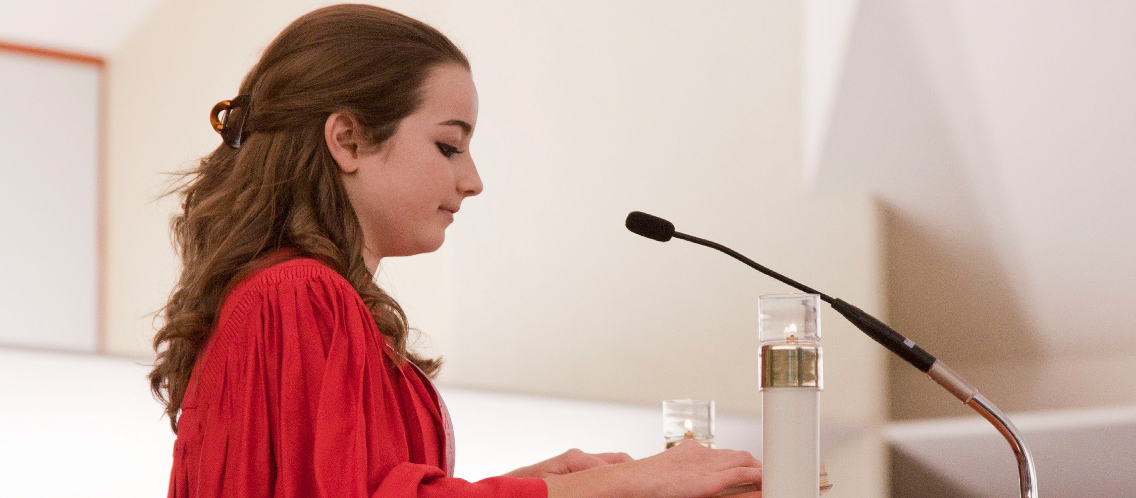
A STEWARDSHIP MOMENT

Twenty-Second Sunday in Ordinary Time Weekend of September 2/3, 2017
In today’s Gospel, Jesus tells his disciples, “Whoever wishes to come after me must deny himself, take up his cross, and follow me.” At the end of the reading Jesus suggests there is great hope in the cross. Today’s followers of Christ recognize they are stewards of his entire legacy, including his cross and that through their mutual sacrifices God’s glory is revealed. They don’t live their lives in Christ only when it is convenient for them. They make a decision to take up their cross and carry it, no matter what the cost is to themselves. Reflect this week on the cross you bear in order to reveal God’s glory.
How do you embrace that cross? How, at times, do you shirk that cross when it is not convenient?

Twenty-Third Sunday in Ordinary Time Weekend of September 9/10, 2017
In today’s second reading Saint Paul enjoins us to be indebted to no one. Debt creates the kind of pressure that impedes our relationship with Jesus Christ. But there is one debt we will always owe and never be able to pay off fully: The debt of showing love to others. We will never reach the place where we can say, “Now I love others
as much as I ought, and that’s enough.” No matter how much we’ve grown in faith we will always be required to grow in love. Good stewards realize that God does not call them just to love those who are easy to love, but to love the unloved and the hard-to-love people in this
world as well. This week, remind yourself: “I am put here as an ambassador of God’s love.”

Twenty-Fourth Sunday in Ordinary Time September 16/17, 2017
Today’s Gospel reading continues Jesus’ instructions on being good stewards of others – the direction that if we love Jesus Christ, we must forgive an individual 77 times. The reading compels us to consider one of the most difficult practices of Christian discipleship. Forgiveness
is the way of Jesus, the way of the cross. Vengeance, bitterness and hatred seem so much easier and certainly more desirable. Forgiveness is a hard road to travel, but it is the only road that leads to life in Christ. Consider this week who you need to forgive.

Twenty-Fifth Sunday in Ordinary Time Weekend of September 23/24, 2017
From an early age, we tend to distort the concept of “fairness”: “I am good. I deserve good things. I am not receiving good things. Something must be wrong. Who’s going to fix it?” We also know the age-old expression: “Who ever said life was fair?” Jesus knew this expression when he offered his parable in today’s Gospel reading. Christian stewards acknowledge, with humility, that they receive good things from the Lord in abundance; even
if these gifts are not the ones they think they need when they need them. Consider which servants you identify with most in the Gospel reading, the ones who demand “fairness”, or that final servant who, seemingly, deserves the least.

International Catholic
Stewardship Council
ICSC@catholicstewardship.org
(800) 352-3452
www.catholicstewardship.com

