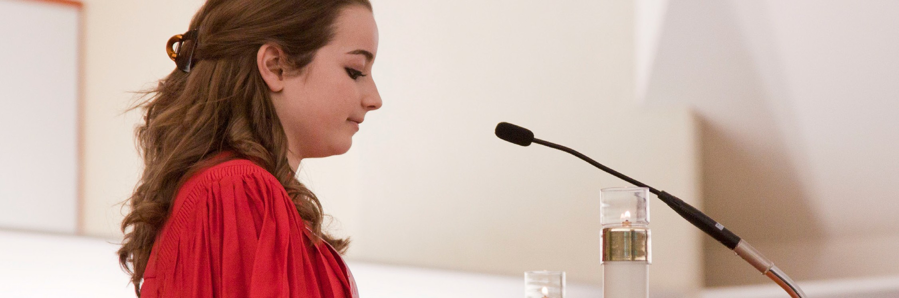
A STEWARDSHIP MOMENT

Feast of the Transfiguration of the Lord Weekend of August 5/6, 2017
Today we celebrate the Feast of the Transfiguration of the Lord, and in today’s Gospel reading we hear it proclaimed that on Mount Tabor, Peter, James, and John caught a glimpse of Jesus’ divinity strong enough to strike fear into their hearts. The event took place shortly after Peter’s confession of faith that Jesus was, indeed, the Messiah. In today’s second reading from Peter, we hear his personal testimony. This comes from
a man who spent more than three years with Jesus. Peter witnessed his humanity. He saw Jesus hungry, tired, and finally, rejected and crucified. But he also saw Jesus feed the 5,000, walk on water, heal the sick, and raise the dead. He saw Jesus in his glory when he was transfigured. He saw Jesus risen from the dead and ascend into heaven with the promise that he is coming again in power and glory. How strong is the stewardship of our own faith? Do we accept Peter’s apostolic witness to Jesus as Christ? Does this testimony help us acknowledge and trust Christ Jesus as our Lord and savior?

Nineteenth Sunday in Ordinary Time Weekend of August 12/13, 2017
Today’s Gospel reveals what miraculous things can happen when one embraces a single-minded faith in Jesus Christ. Peter gets out of a wind-tossed boat when the Lord calls him. His faith is tested by his obedience to Jesus who is calling him out onto the water. In the midst of the waves and the wind, Peter gets out of the boat and walks toward Jesus. Good
stewards heed Christ’s call to them. Sometimes that call directs them to take on seemingly impossible challenges. This week, reflect on how the Lord could be calling you out of the safety of your own “boat” to take on the impossible.

Feast of the Assumption of the Blessed Virgin Mary Tuesday, August 15, 2017
Today we celebrate the Feast of the Assumption; the day we recall Our Blessed Mother being assumed into heaven and crowned queen. In the Gospel reading we hear proclaimed
once again the Canticle of Mary, recorded in the Gospel of Luke (1:46-55). It is the Virgin Mary’s song of joy in response to her cousin Elizabeth’s greeting (Luke 1:41-45), and summarizes Mary’s deep faith and trust in God. “My soul magnifies the Lord…” Take a few moments and pray this stewardship prayer. Consider its implications for your
life. How do you magnify the Lord? How do you make God “bigger” in your day-to-day world? How do you share God’s compassion with others, especially the poor?

Twentieth Sunday in Ordinary Time Weekend of August 19/20, 2017
In today’s first reading, the Lord speaks through the prophet Isaiah during a time of political dissolution and moral decline. The prophet had warned of God’s judgment against people for the feelings of self-importance they found in their possessions, and condemned them for various forms of economic injustice such as exploiting the poor and immigrants. Good stewards know that Isaiah’s message is
as compelling today as it was in the time of the kingdom of Judah: Do the right thing. Offer justice and compassion
toward others. Be honest in all your dealings. And remember to observe the day of the Lord.

Twenty-First Sunday in Ordinary Time Weekend of Aug 26/27, 2017
Saint Paul reminds us in today’s second reading that the ultimate origin of everything is God. Since everything comes from God, we are God’s own. We can never put God in our debt. There is absolutely no negotiating with God. Every breath we take is a gift. Every good deed we perform is grace.
Good stewards realize they are created and called to make the beauty, greatness, compassion and justice of God and his gifts known throughout the world. The stewardship
question for us is whether we are willing to embrace this call, acknowledge our dependence on God and give our lives over to him completely for this purpose.

International Catholic
Stewardship Council
ICSC@catholicstewardship.org
(800) 352-3452
www.catholicstewardship.com

