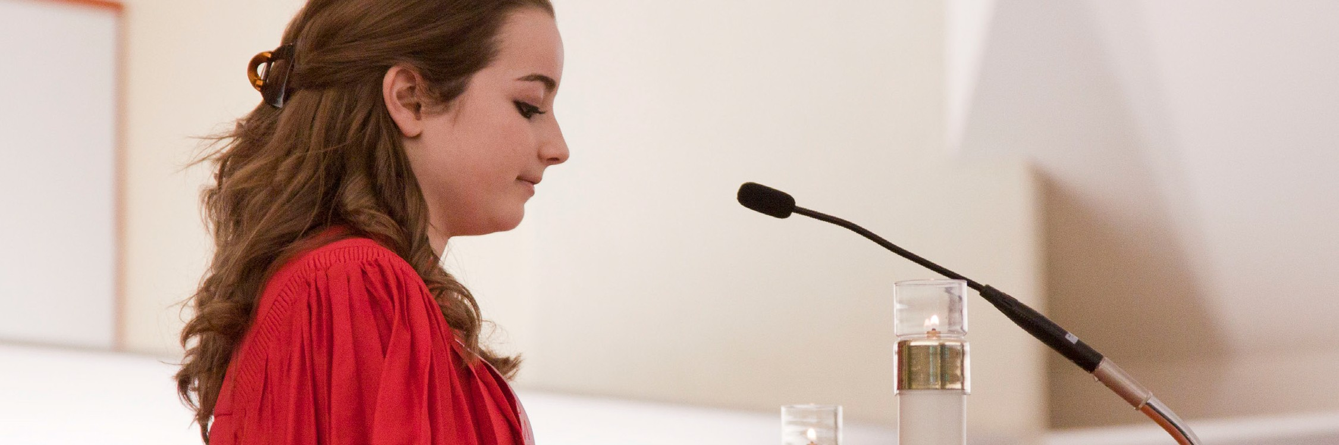
A STEWARDSHIP MOMENT

Thirteenth Sunday in Ordinary Time Weekend of July 1/2, 2017
In today’s Gospel, Jesus minces no words: “whoever does not take up his cross and follow after me is not worthy
of me.” Few of us will be called to die the way Jesus did. But to be his disciples means having the willingness to lay down our lives with him and for him. Exercising good stewardship of the Gospel requires taking up one’s cross daily and following Jesus. There will be dying to do on our way to the Father. It could be unfair treatment, health problems, fatigue, frustration at work, failed relationships, loneliness or sadness. If we, like Jesus, encounter and accept suffering, we will bring the hope of the cross to others. There is no cross the Lord’s love cannot transcend. In your reflections this week, consider how your cross, no matter how heavy, might become an instrument of hope and Christ’s love.

Fourteenth Sunday in Ordinary Time Weekend of July 8/9, 2017
One of the most well known and beloved passages in scripture is the gentle invitation of our Lord in today’s Gospel reading: “Come to me, all you who labor and are burdened, and I will give you rest.” When we need physical rest, we sleep or take a nap. When we need
emotional rest, we sometimes take a vacation. But how do we find spiritual rest? How do we discover Christ’s peace as we grapple with the complex issues of life deep in our hearts? Good stewards find their rest in the Lord. Reflect this week on what you do to welcome the peace of Christ into your heart.

Fifteenth Sunday in Ordinary Time Weekend of July 15/16 2017
In today’s reading from the prophet Isaiah, there is a guarantee that the unleashing of God’s Word will bear
much fruitfulness in the world. The Word of God will accomplish whatever God sends it forth to do. His Word is given to us as a gift to be nurtured, shared and made to “bear fruit.” The question is whether or not we are exercising good stewardship over God’s Word. Have we been “fruitful” with God’s Word? Have we unleashed
God’s Word? Do we share God’s Word or do we leave that task to others?

Sixteenth Sunday in Ordinary Time Weekend of July 22/23, 2017
In today’s second reading, Saint Paul bids us to take comfort in knowing that when God invites us to pray to him, he knows our true needs, even if we do not. The Holy Spirit intercedes and prays for us even if we can’t come
up with appropriate words; even when we don’t have a clue what to ask for. We are not left alone. Good stewards know that prayer is an important part of living a life in Christ. The important thing is to make space for God. Do we let God into our hearts? Do we make room for the Holy Spirit to pray within us?

Seventeenth Sunday in Ordinary Time Weekend of July 29/30, 2017
A profound stewardship prayer is offered by the young king Solomon in today’s first reading. He asks the Lord to give him an understanding heart, compassion towards God’s people and the insight to distinguish right from wrong. An understanding heart, or wisdom, is a gift from God. It is a gift that enables us to make good decisions and prudent choices. Cultivating and sharing this gift is essential, especially when poor decisions and lack of compassion have consequences that can adversely affect
the lives of others. Do we exercise good stewardship over the gift of wisdom? Do we share our compassionate hearts with others?

International Catholic
Stewardship Council
ICSC@catholicstewardship.org
(800) 352-3452
www.catholicstewardship.com

