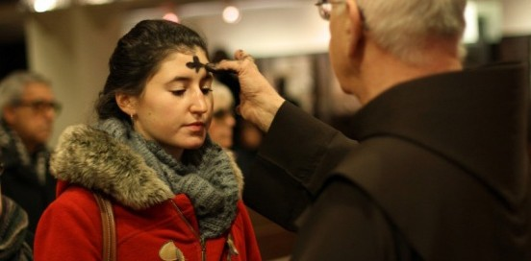
A STEWARDSHIP MOMENT

First Sunday of Lent Weekend of March 4/5, 2017
At the beginning of this Lenten season we hear proclaimed the story of Jesus’ temptation in the desert. He responds to the first temptation by saying that one does not live by bread alone but on every word that comes forth from the mouth of God. The season of Lent invites us to consider how we nourish our hearts, how we act as stewards of the Word of God entrusted to us. A good reflection for the week: What do we live on? What keeps us going? Could it be possessions, prestige, the need to be in control, the need for security, addictions? Or the fervent desire to listen to God’s word?

Second Sunday of Lent Weekend of March 11/12, 2017
In today’s second reading, Timothy is issued a strong direc- tive: “Bear your share of hardship for the gospel with the strength that comes from God.” For the early Christians this could mean torture and execution. For most Christians today enduring hardship for the gospel might include accepting ridicule or mockery, or the suggestion that we lack sophis- tication. Nevertheless, in his letters, Saint Paul is adamant that we should not be ashamed of being followers of Christ. Good stewards are not ashamed of their allegiance to Christ. They do not hide their faith. Reflect on this question: Are you willing to speak about following Christ Jesus no matter who your listeners happen to be?

Third Sunday of Lent
Weekend of March 18/19, 2017
Jesus’ longest-recorded conversation with anyone is the one he has with the Samaritan woman at the well. She discovers she can be honest with Jesus and goes and tells others about him. She gives witness. She’s not the most certain, thorough or even convincing witness. But her witness is enough. It is inviting, humble, non-judgmental and sincere. What is the quality of our witness? How do our words and actions give daily testimony on behalf of Christ? During this season of Lent, how might we do a better job at proclaiming the risen Lord in word and deed?

Fourth Sunday of Lent Weekend of March 25/26, 2017
Saint Paul gives us a wakeup call. As stewards of the light of Christ, we are to reflect that light with the help of the Holy Spirit. If Christ’s work has transformed and illuminated our lives, there should be a change. The light of Christ’s active presence should be at work in us. And as the light shines within us, we take on the properties of that light and we shine too. We are used by God to shine the light of Christ in the lives of others. A challenging Lenten reflection: Is the light of Christ shining in our hearts? Is the light of Christ reflecting out from us to others?

International Catholic
Stewardship Council
ICSC@catholicstewardship.org
(800) 352-3452
www.catholicstewardship.com

