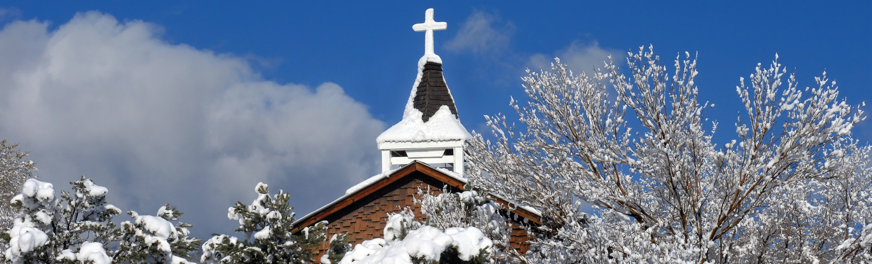
A STEWARDSHIP MOMENT

Solemnity of the Blessed Virgin Mary, the Mother of God Weekend of December 31/January 1, 2017
The encounter between God and Moses in today’s first reading is awe-inspiring. God bestows three blessings upon Moses and directs him to extend those blessings to others: The Lord blesses you and keeps you. The Lord lets his face shine upon you and be gracious to you. The Lord looks upon you kindly and gives you peace. Good stewards realize these blessings are showered upon them in a unique and special way each time they re- ceive the Eucharist, and exercising good stewardship of the Lord’s blessings in this sacrament begins by receiv- ing these gifts with profound gratitude. Perhaps it would be a good idea this week to memorize these marvelous blessings and repeat them to yourself frequently. Make them part of your morning prayer each day.

Solemnity of the Epiphany of the Lord Weekend of January 7/8, 2017
In today’s second reading we hear the teachings of Saint Paul to the members of the Church at Ephesus. He pro- claims that he, and they, are stewards of the Gospel of Jesus Christ, and therefore stewards of God’s loving, unifying and inclusive grace. He also proclaims that the Holy Spirit is at work within each of them, if only they would be open to the Spirit. Today, our world races by with intolerance, violence, desperate poverty, fear and division. At the beginning of this New Year, perhaps it is appropriate to reflect on Saint Paul’s words and ask ourselves how we can be good stewards of the Gospel today. How will we allow the Holy Spirit to work within us? How can we be better stewards of Christ’s justice and peace?

Second Sunday in Ordinary Time Weekend of January 14/15, 2017
As the prophet Isaiah proclaims in the first reading, the Lord continues to remind us that we are his servants. Imag- ine the Lord speaking these words to you personally: “You are my servant. Through you I show my glory. I formed you as my servant from your mother’s womb. I will make you a light so that you may shine the light of my salvation everywhere you go, and reveal my glory to everyone you encounter. I will give you the strength to do this. I will give you confidence. Heed my words, for I have spoken to you.” What would your response be to the Lord? Would it be different from the response you give the Lord now?

Third Sunday in Ordinary Time Weekend of January 21/22, 2017
In today’s Gospel we hear Jesus calling Peter, Andrew, James and John to follow him. Following Jesus was a dif- ficult journey for these first disciples. It is difficult for us today. Jesus wants to teach us his way of thinking, act- ing and encountering the world. But it is not easy for us to embrace his teaching. Good stewards of Jesus’ teach- ings realize they are on a spiritual journey, and must learn from their experiences of being open and resistant to the Gospel. They realize the need to be liberated from those actions that keep them from enjoying a closer friendship with Jesus. What is it in our lives that we need to reform? What keeps us from revealing God’s glory to others?

Fourth Sunday in Ordinary Time Weekend of January 28/29, 2017
In today’s Gospel, Jesus begins his Sermon on the Mount with a series of blessings, the Beatitudes. The Beatitudes are a summary of the fundamental attitude of a Christian steward. Make it a point to reflect on this Gospel reading during the week. Identify the blessing you relate to the most. Which one is the most challenging for you?

International Catholic
Stewardship Council
ICSC@catholicstewardship.org
(800) 352-3452
www.catholicstewardship.com

